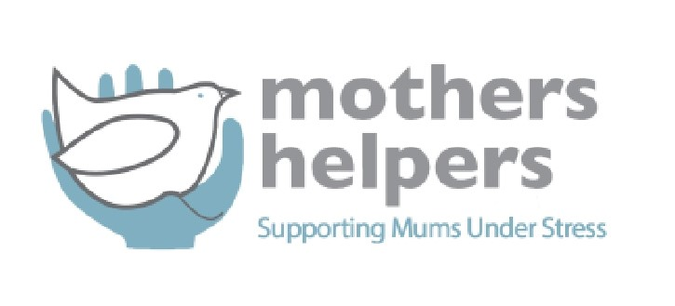

**Job Title: Māori Maternal Mental Health Consultant**

**Location:** Nelson office or anywhere in Aotearoa if working from home  
**Employment Type:** Contract  
**Consults with:** Kristina Grace, Service Manager

**Position Overview**

We are seeking a **Māori Maternal Mental Health Consultant** to guide, support, and enhance the cultural responsiveness of maternal mental health services delivered by Mothers Helpers. This role plays a vital part in developing professional learning opportunities, advising on existing mental health services, and fostering strong relationships with iwi, hapū, and Māori community leaders.

The ideal candidate will bring in-depth knowledge of tikanga Māori, a strong background in mental health (particularly maternal mental health), and a commitment to improving outcomes for wāhine Māori and their whānau.

**Key Responsibilities**

* **Workshop Development & Delivery**  
  Design and facilitate a **professional development workshop** focused on enhancing cultural safety and competency within maternal mental health services, incorporating Te Ao Māori perspectives and mātauranga Māori.
* **Service Advisory Role**  
  Review and provide expert cultural advice on **existing maternal mental health services**, policies, and resources to ensure they are culturally safe, inclusive, and responsive to the needs of wāhine Māori and whānau.
* **Relationship Building**  
  Proactively **arrange and lead introductory meetings** with local iwi, hapū, and Māori health providers to build trust, strengthen partnerships, and promote collaborative care approaches.
* **Cultural Consultation**  
  Act as a cultural advisor within multidisciplinary teams, supporting the integration of kaupapa Māori frameworks into service design and delivery.

**Key Requirements**

* Proven experience in Māori health, mental health, or maternal wellbeing services.
* Strong knowledge of Te Ao Māori and tikanga
* Preference for knowledge of te reo Māori (fluent or conversational).
* Demonstrated experience in facilitating workshops or training programmes.
* Deep understanding of the systemic challenges facing wāhine Māori in maternal mental health.
* Excellent communication and relationship-building skills, particularly with iwi and Māori organisations.
* Commitment to Te Tiriti o Waitangi and equity in healthcare.

**Desirable Qualifications**

* Tertiary qualification in Māori Health, Mental Health, Social Work, Midwifery, or a related field.
* Previous experience in consultancy or advisory roles within a health or social services context.

**We Offer**

* A culturally safe and supportive working environment.
* Opportunities to lead transformational change in maternal mental health services.
* Strong commitment to te ao Māori and partnership with iwi and whānau.

**To Apply:**  
Please send your CV and a cover letter outlining your relevant experience and connection to this kaupapa to Kristina Grace: kristinap@mothershelpers.org.nz